CTF – User Manual

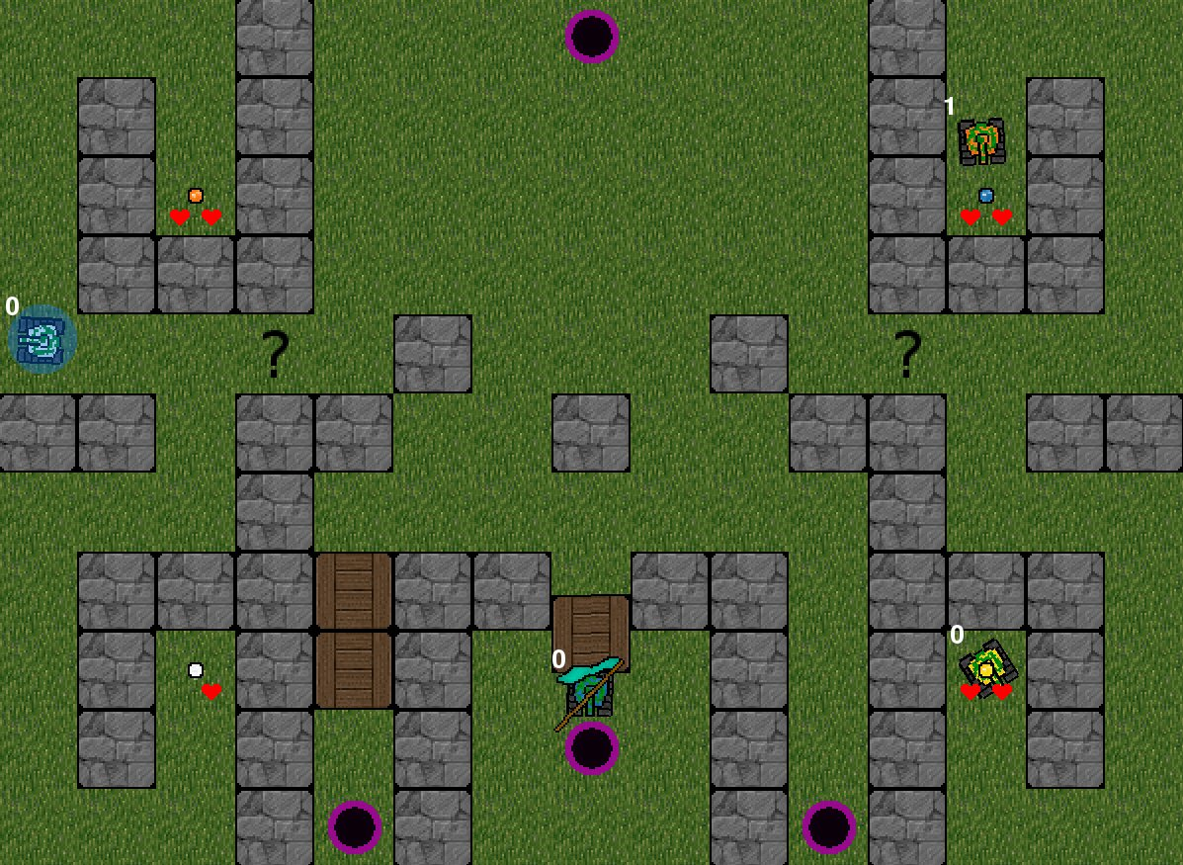

Adam Andersson
Aleksi Evansson
Ludvig Westerdahl

Table of Contents
1. About 3
2. Starting a game 4
3. Controls 4
4. Obstacles 4
5. Playing the game 5
6. Powerups 5
7. Ending the game 5
8. Potatopack 6

1. About
The game is capture the flag (or CTF for short) where you have to reach ten points to achieve victory. We've been handed a basic version of CTF where we have added our own features to make our game uniqe. Following pages gives instructions on how you play the game and what specific features the game have. The game have been developed by gamers for gamers and we hope you will have as much fun and get as addicted with the game as we have.

2. Starting a game
To start Capture the Flag make sure you're in the same directory as ctf.py, then start a terminal and write: ”python3 ctf.py”. A start screen pops up and music starts playing, the music will continue to play as long as you play the game. In the first screen that you enter you have to choose how many players there should be, zero, one or two (zero players means that only AI players will play). You can use the keyboard keys corresponding to the number of players or use the mouse to click on the text, next you will have to choose what map you want to play and here you can also use both keyboard and mouse. Now you should be all set to start playing!

3. Controls
The following controls is available in the game:
Player 1:
Move forward – Arrow up
Move backward – Arrow down
Rotate left – Arrow left
Rotate right – Arrow right
Shoot missile – Enter

Player 2:
Move forward – W
Move backward – S
Rotate left – A
Rotate right – D
Shoot missile – Space

Other:
Pause – P
Unpause – U
Exit game – ESC

4. Obstacles
In the game you will encounter several obstacles and they're listed below:
Stonewalls – Indestructable walls that you cant get past
Wood boxes – Boxes that can be shot down with one missile
Steel blocks – Blocks of steel that you can push but not destroy
Portals – If you enter a portal you will be teleported to another one (or the same) at random. Use at own risk!

5. Playing the game
The goal of the game is to get a score of ten or more. You can achieve this by either killing opponents or capturing the flag but be careful, dying will make you loose points!
How many points you can earn/loose is listed below (you cannot drop below 0 in score):
Capturing the flag – 3p
Killing an opponent – 1p
Dying – -2p
All players have 2hp and each missile deals 1hp damage, if you loose all your hp you die, loose two points and gets respawned at your base with full hp. You can also die from overheat, you get overheated for two seconds if you shoot a missile, wich means that if you shoot when you are overheated you will loose two points and get respawned at your base with full hp.

If you die you will recieve respawn protection to prevent people from camping your base. Respawn protection makes you invulnerable to other peoples missiles for four seconds, you can still die and loose points to overheat.

6. Powerups
In the game there are powerups and powerdowns that can be picked up, the places where you can pick them up is represented by a questionmark. The powerups and powerdowns are only active for a little while so you have to watch out! The different kinds of powerups and powerdowns you can get are:
Increased speed – Your maximum velocity increases
Automatic fire – You don't get overheated when firing missiles
Increased damage – Your missiles instantly kills your opponents
Sticky ammunition – Your missiles slows down your opponents for a little while
Shield – You get a shield that prevents you from taking damage
Reduced speed – Your maximum velocity decreases
Extreme overheat – You're overheated so you can't fire missiles without dying

7. Ending the game
When a player has reached ten points or someone presses ESC or the X button in the top right corner the game ends and you reach a score screen where you can see how many points each player has gathered. If you press ESC or the X button again the game will exit and the window will close.

8. Potatopack
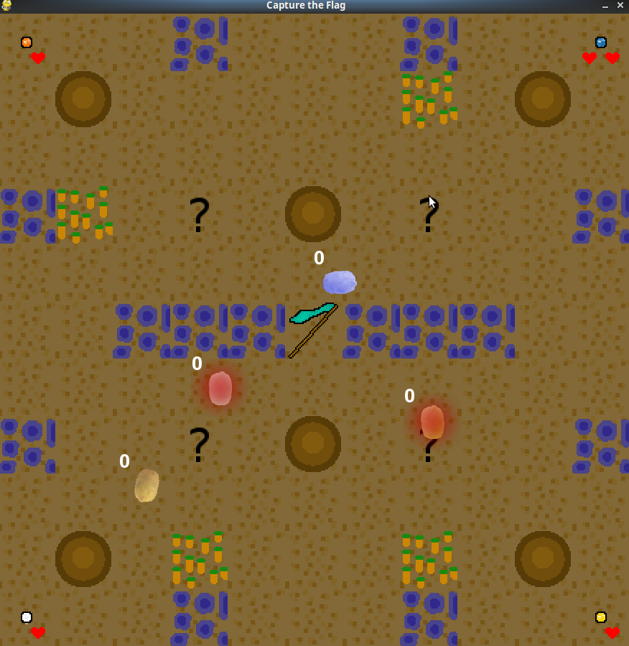
There is a graphicspack where you fight to rule the potatofield! Instead of a tank you drive a potato and you shoot smaller potatos instead of missiles. Wooden boxes are replaced with carrotpatches, stonewalls with water and steel boxes are now grey potatoes. This graphicspack is ready and included but isn't applied so you can choose it yet, we didn't get that to function in time. What you can do is to open the file pack_file.txt in the folder ”data” and change the word ”standard” to ”potato” and vice versa to choose what pack you want to play with.
fig: Picture of the potatopack

